**Plus971 Cybersecurity**

OSINT

**11th September 2023**

**Using the image below, what is the profile picture of the owner of the picture.**

1. Download the image
2. Upload the image to jimpl.com and get the exif data.
3. Google the copyright owner
4. Go to his twitter and see that his profile pic is a cat
5. 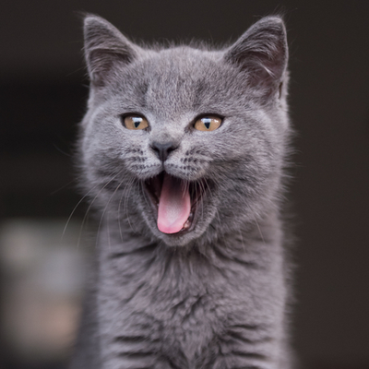

**What's the color of the shirt the girl is wearing behind Shahen instagram profile.**

1. Go to <https://inflact.com/> create a website
2. Google shahenjit singh in google and find his instagram tag
3. Light Blue

**what was the special offer on the heat.net website on january 5 2001**

1. Go to internet archives wayback machine
2. Search for heat.net
3. Look for january 5th 2005 in the calender
4. Scroll through the website
5. The offer is:
6. *“Sign-up for SegaNet for only $9.95/month”*

**Based on the ip address below, which company owns the ip address**

1. <https://www.whatismyip.com/ip-whois-lookup/> and look up the ip’s
2. 54.239.28.85 - Amazon Technologies Inc.
3. 142.251.35.174 - Google LLC

**Who is Thomas Straussman**

1. What is his cat name: GoTank
   1. In the replies section we see a post that francesca has made referring to a cat names Gotank as *“My precious lil furbaby - Gotank”*
   2. And thomas commented in the post *“Precious 😄💛”*
2. Name of his fiance: Francena Hodgelink
   1. In his twitter bio we can see *“❤ Francesca ❤”*
   2. And taking a look at his following list we can see the name of his fiance
3. Favorite Holiday: Christmas
   1. His twitter description *“Buddha used to say "Peace comes from within, not from without". But for me it comes from X-mas ☸✨”*
4. *OR: just google his name and steal a mindmap from the images.*
5. 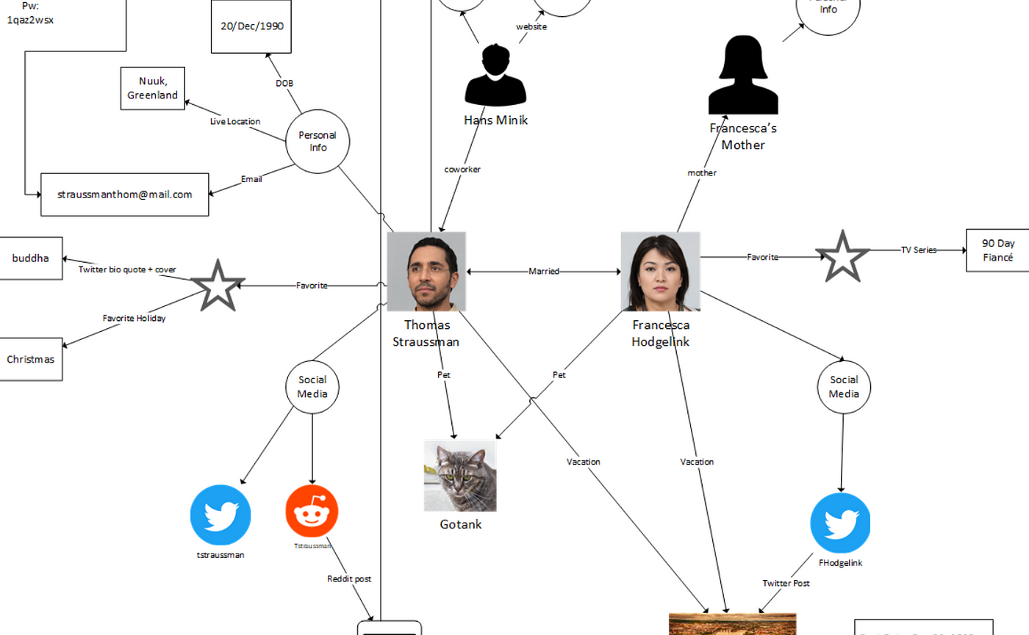

**What is the make and month of registration for the car below:**

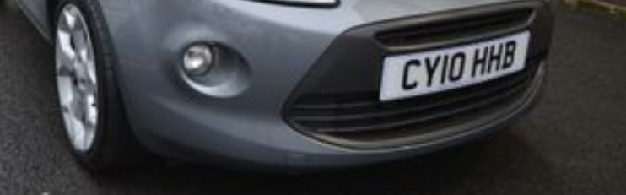

1. Search for the license number in google.
2. Go to <https://car-check.co.uk/check/CY10HHB>
3. And here we can find all the answers
4. Make: Ford KA Titanium
5. Month: June

**What is the name of the building**

1. Open the image
2. Right Click and hit search with google
3. Look at visually similar images and there we can see the name axel towers

**Rabbit 2022**

1. Step 0
   1. The first password is the MD5 hash for summer
   2. 6b1628b016dff46e6fa35684be6acc96
2. Step 1
   1. Look for the scarf which is purple
   2. Bb7aedfa61007447dd6efaf9f37641e3
3. Step 2
   1. 727774447777 translates to paris when typed on an old phone's keypad.
   2. Ccbee73cd81c7f42405e1920409247ec
4. Step 3
   1. 14:17 using SunCalc
   2. A3c2c70e2d306f1ea5f270337eeb31cb
5. Step 4
   1. Found a ship that went under the tower bridge in london that was named gothenburg which is a city in sweden
   2. 88e52ee42fd090896f69d0d71e339d94
6. Step 5
   1. Google the town of sweden in the usa which is sweden, new york
   2. Find their official website
   3. And use the wayback machine to go back 15 years to see a picture of the town hall
   4. Use google street view and select 2022 for the streetview
   5. And there is a lady speaking on the phone in a infiniti g35
   6. 2d94892c7f81e83990d63e8e59fd1a5b
7. Step 6
   1. Beijing, london and rio are all countries that hosted the summer olympics
   2. The next olympic games were set to take place in japan and we just explored the area
   3. 2b849500e4585dab4196ec9a415edf8f